 

NAME: Md Akbal

STUDENT ID: 10702

BSC.(CS&DF)

TASK WEEK 4

MOQUPS

TASK 1

Drag and drop some of the objects in Stencils that you can use to create wireframe. Do not limit with

what is just mentioned below.

a. Rectangle

b. Link

c. Heading

d. Paragraph

e. Image Placeholder

f. Banner

g. Search

h. Menus & Navigation

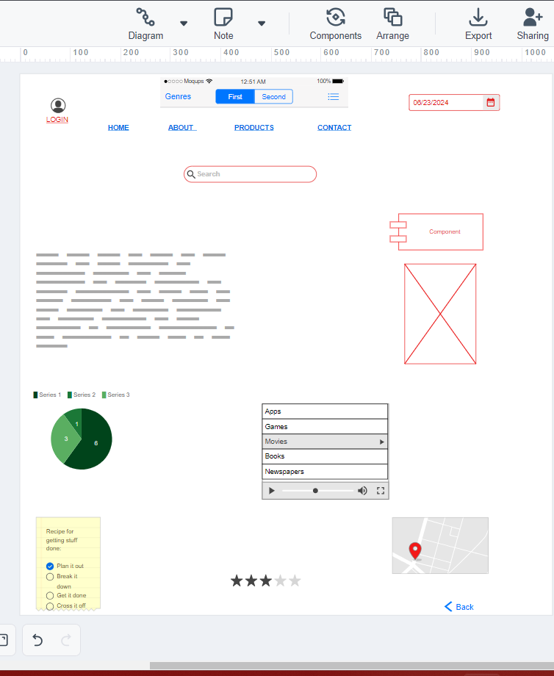

TASK 2

Design the below like wireframe structure. Use your own creativity. 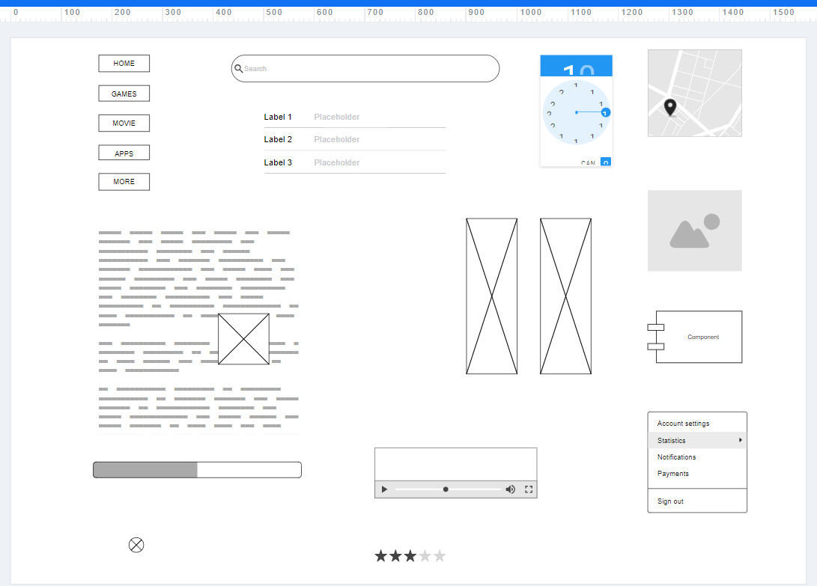

TASK 3

Create a mockup design like your college website’s contact us page. Use your own creativity for this design.

